|  |  |
| --- | --- |
| **Website Design Document**  Group Name: QuiQuoQua  Website Link:  Hypermedia Application project  Academic year 2023 – 2024  05 May 2024  Version 0.0 | |
| |  |  |  | | --- | --- | --- | |  | *Authors:*  Fabiana Marino  Tommaso Pasini  Dario Tedesco | - fabiana.marino@mail.polimi.it - tommaso1.pasini@mail.polimi.it  - dario.tedesco@mail.polimi.it | | |  |  |  | | --- | --- | --- | |  | *Professor:*  Franca  Garzotto |  | |

**Table of contents:**

**Abstract** 2

**1.** **Introduction** 5

1.1 Purpose and Scope 5

1.2 Reference Documents 5

1.3 Document structure 5

**2.** **Inspection** 6

2.1 Method 6

2.1.1 Nielsen 6

2.2 Study design 7

2.3 Study execution 8

2.3.1 Tasks Identification 8

2.3.2 Metrics Definition 8

2.4 Results 8

2.4.1 Table 9

2.4.2 Score analysis 9

2.4.3 Conclusions 14

**3.** **User Testing** 15

3.1 Method 15

3.2 Study design 15

3.2.1 User Profile Definition 15

3.2.2 Variables 15

3.2.3 Tasks 15

3.3 Study execution 15

3.3.1 Execution 15

3.3.2 Data 15

3.4 Results 15

3.4.1 Analysis 15

**4.** **Conclusion** 16

4.1 Usability Evaluation VS. User Testing 16

4.2 Suggestions for Improvements 16

4.2.1 Problems 16

4.2.2 Suggestions 16

4.3 Observations 16

**5.** **Annex** 17

5.1 Inspection 17

5.1.1 Fabiana Marino 17

5.1.2 Tommaso Pasini 17

5.1.3 Dario Tedesco 17

5.2 User Testing 17

5.2.1 User’s survey 17

# **Abstract**

(3 - 5 linee che descrivono di cosa tratta il documento)

# **C – IDM Diagram**

(Descrizione cos’è e a cosa serve C-IDM + Diagramma + Commento)

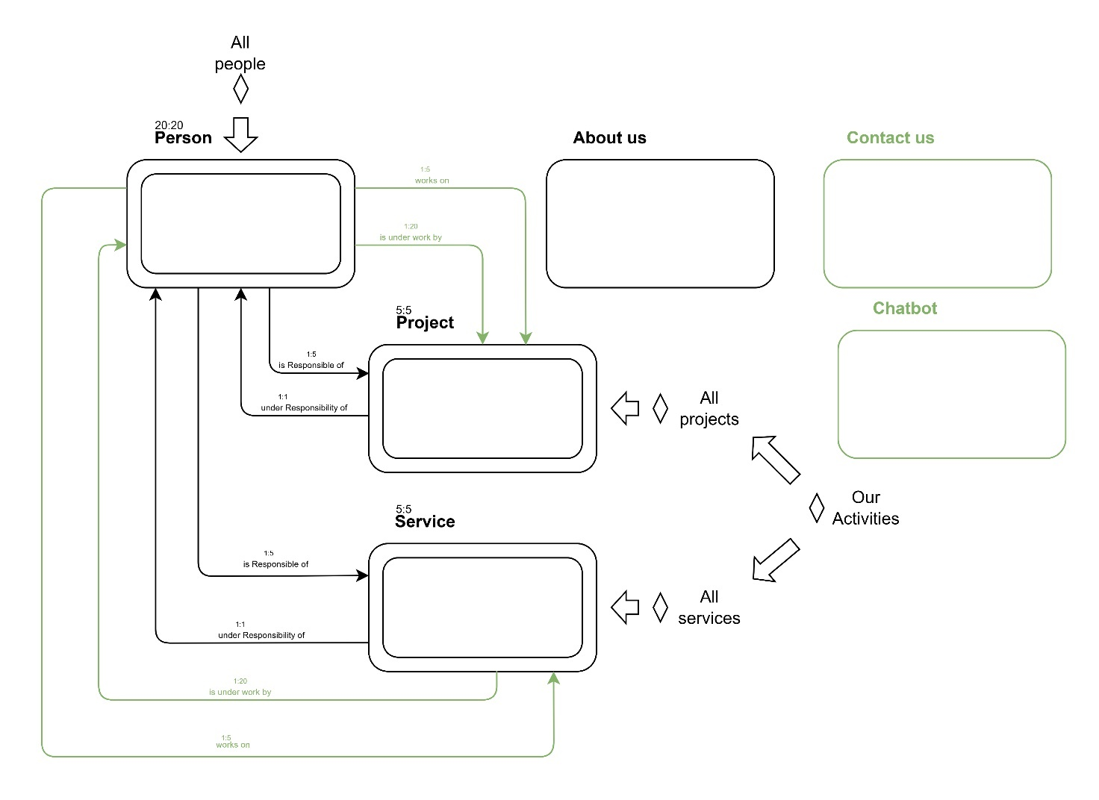

# **Content Tables**



## Landmarks

## Topic Tables

|  |  |
| --- | --- |
| TOPIC: “ABOUT US” | |
| Page element | **Element description** |
| Title: | About Us |
| Description: | [Text (max 500 words), n Images] |

|  |  |
| --- | --- |
| TOPIC: “CONTACTS” | |
| Page element | **Element description** |
| Title: | Contacts |
| Description: | [Text (max 20 words), n Images] |
| Phone Numbers: | Numbers |
| E-mail: | Text |
| Social media: | Image (Thumbnail) |
| Address: | [Text (max 20 words), Map] |
| Submit Message Form: | Form |

|  |  |
| --- | --- |
| TOPIC: “OUR ACTIVITIES” | |
| Page element | **Element description** |
| Title: | Our Activities |
| Description: | [Text (max 500 words), n Images] |
| Current Projects: | [Image (Logo), Text (Title)] |
| Most Liked Service: | [Image (Logo), Text (Title), Rating] |

|  |  |
| --- | --- |
| TOPIC: “CHATBOT” | |
| Page element | **Element description** |
| Title: | AscoltoSicuro / ParlaProtetto |
| Icon: | Image |
| Messages: | Text (max 400 char) |
| Submit Messages Chat: | Text (max 400 char) |

## Kind of Topic Tables

|  |  |
| --- | --- |
| KIND OF TOPIC: “PERSON” | |
| Page element | **Element description** |
| Person Full Name: | Text (max 30 char) – “Person Name” |
| Profile Picture: | Image |
| Role: | Text (max 30 char) |
| Joining Date: | Date |
| Biography: | Text (max 30 words) |
| Related project as responsible: | [Image (Logo), Text (Title)] |
| Related project as team member: | [Image (Logo), Text (Title)] |
| E-mail: | Text |
| CV: | Text (PDF Link) |
| Linkedin: | [Text (Linkedin profile name), Image (Logo)] |

|  |  |
| --- | --- |
| KIND OF TOPIC: “PROJECT” | |
| Page element | **Element description** |
| Title: | Text (max 50 char) – “Project Name” |
| Photo: | Image |
| Presentation: | Text (max 100 words) |
| Description: | [Text (max 400 words), n images] |
| Starting Year: | Date |
| Current State: |  |
| Responsible: | Text (Person full name) |

|  |  |
| --- | --- |
| KIND OF TOPIC: “SERVICE” | |
| Page element | **Element description** |
| Title: | Text (max 50 char) – “Service Name” |
| Photo: | Image |
| Description: | [Text (max 400 words), n images] |
| Availability: | [Days, Time] |
| Duration: | Time |
| Rating: | Number |
| Submit Rating Form: | Form |
| Testimonials: | n Text (max 500 char) |

## Group Tables

|  |  |
| --- | --- |
| GROUP: “OUR TEAM” | |
| Page element | **Element description** |
| Title: | Text (max 50 char) – “Our Team” |
| Description: | Text (max 100 words) |
| Members Preview: | List of [Image (Profile picture), Text (Person full name), Text (Person Role)] |

|  |  |
| --- | --- |
| GROUP: “PROJECTS” | |
| Page element | **Element description** |
| Title: | Text (max 50 char) – “Our Projects” |
| Description: | Text (max 100 words) |
| Project Preview: | List of [Image (Logo), Text (Project name), Date] |

|  |  |
| --- | --- |
| GROUP: “SERVICES” | |
| Page element | **Element description** |
| Title: | Text (max 50 char) – “Services” |
| Description: | Text (max 100 words) |
| Service Preview: | List of [Image (Logo), Text (Service name), Rating] |

## Multiple Group Tables

**2**

# **Wireframes**



## Header and Footer

## Centre Topic Page

## Our Activities Topic Page

## Person Kind of Topic Page

## Project Kind of Topic Page

## Service Kind of Topic Page

## All Person Group Page

## All Project Group Page

## All Service Group Page

## Homepage

# **Interaction Scenarios**



## Scenario 1

(Descrizione + Screenshot)

## Scenario 2

(Descrizione + Screenshot)

## Scenario 3

(Descrizione + Screenshot)

# **Database Design**

1. 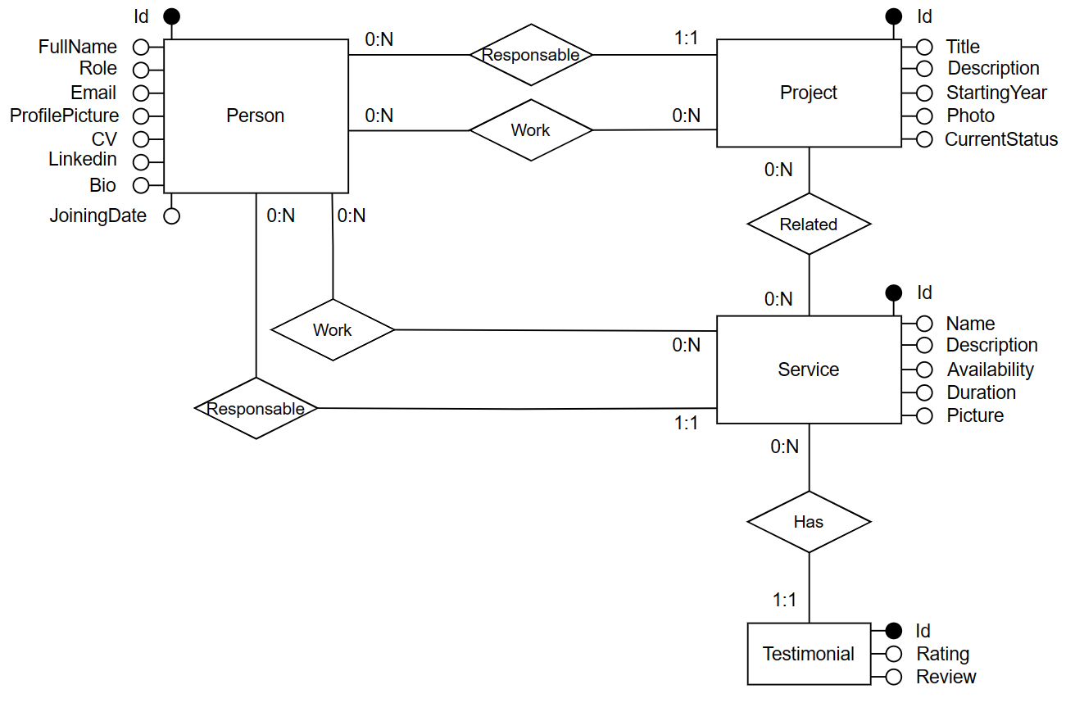

## ER Diagram

## Logic Table Description

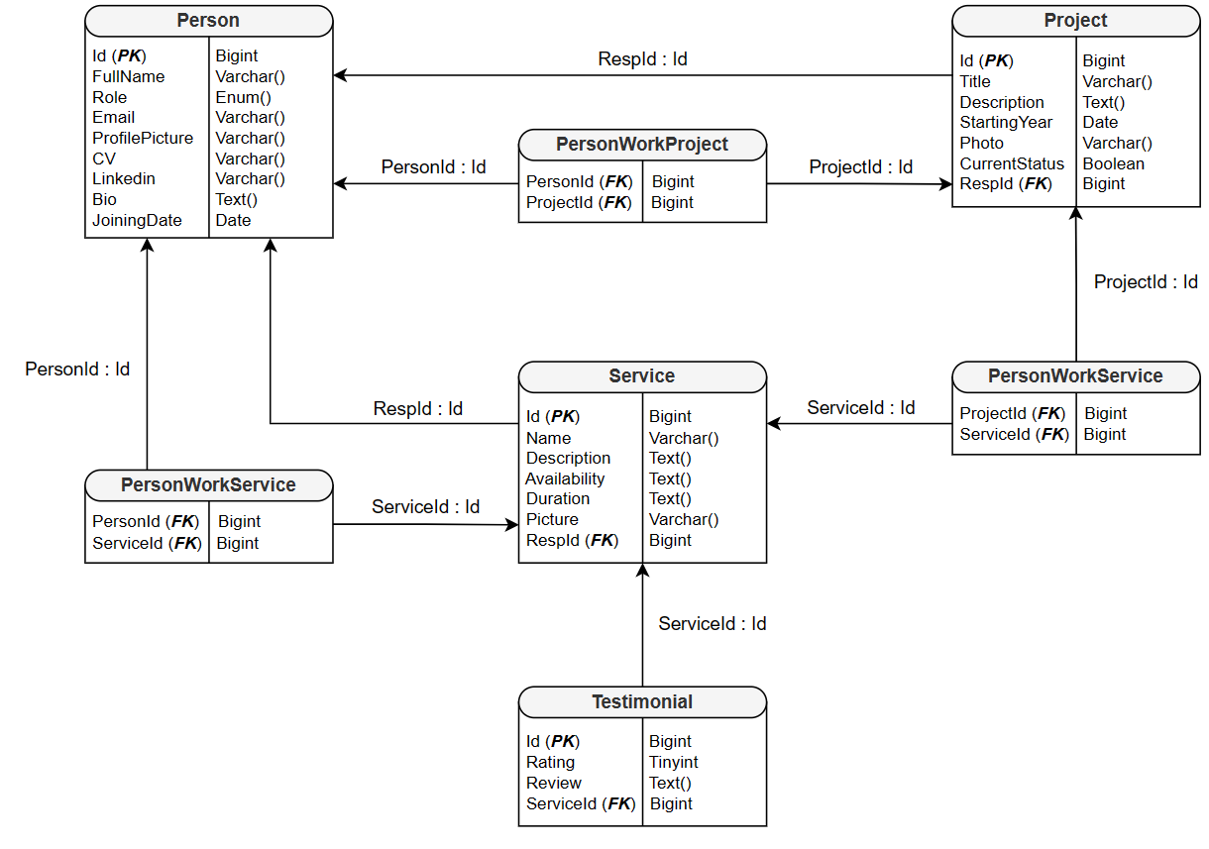

# **Annex: Abstract Pages**

All the pages present the same landmarks always available …

## Topic Tables

|  |  |  |
| --- | --- | --- |
| TOPIC: “ABOUT US” | | |
|  | **Page element** | **Element description** |
| TOPIC CONTENTS | Title: | About Us |
| Description: | [Text (max 500 words), n Images] |
| TRANSITION LINK | Link: | Back previous page |
| Link: | Our Team |
| Link: | Chatbot |
| Link: | Projects |
| Link: | Services |

|  |  |  |
| --- | --- | --- |
| TOPIC: “CONTACTS” | | |
|  | **Page element** | **Element description** |
| TOPIC CONTENTS | Title: | Contacts |
| Description: | [Text (max 20 words), n Images] |
| Phone Numbers: | Numbers |
| E-mail: | Text |
| Social media: | Image (Thumbnail) |
| Address: | [Text (max 20 words), Map] |
| Submit Message Form: | Form |
| TRANSITION LINK | Link: | Chatbot |

|  |  |  |
| --- | --- | --- |
| TOPIC: “OUR ACTIVITIES” | | |
|  | **Page element** | **Element description** |
| TOPIC CONTENTS | Title: | Our Activities |
| Description: | [Text (max 500 words), n Images] |
| Current Projects: | [Image (Logo), Text (Title)] |
| Most Liked Service: | [Image (Logo), Text (Title), Rating] |
| TRANSITION LINK | Link: | Projects |
| Link: | Services |
| Link: | Our Team |
| Link: | Chatbot |

|  |  |  |
| --- | --- | --- |
| TOPIC: “CHATBOT” | | |
|  | **Page element** | **Element description** |
| TOPIC CONTENTS | Title: | AscoltoSicuro / ParlaProtetto |
| Icon: | Image |
| Messages: | Text (max 400 char) |
| Submit Messages Chat: | Text (max 400 char) |
| TRANSITION LINK | Link: | Close chatbot |

## Kind of Topic Tables

|  |  |  |
| --- | --- | --- |
| KIND OF TOPIC: “PERSON” | | |
|  | **Page element** | **Element description** |
| KIND OF TOPIC CONTENTS | Person Full Name: | Text (max 30 char) – “Person Name” |
| Profile Picture: | Image |
| Role: | Text (max 30 char) |
| Joining Date: | Date |
| Biography: | Text (max 30 words) |
| Related project as responsible: | [Image (Logo), Text (Title)] |
| Related project as team member: | [Image (Logo), Text (Title)] |
| E-mail: | Text |
| CV: | Text (PDF Link) |
| Linkedin: | [Text (Linkedin profile name), Image (Logo)] |
| TRANSITION LINK | Link: | Project supervised |
| Link: | Project participated as team member |
| GROUP LINK | Link: | Back to Our Team |
| Link: | Next / Previous Person |

|  |  |  |
| --- | --- | --- |
| KIND OF TOPIC: “PROJECT” | | |
|  | **Page element** | **Element description** |
| KIND OF TOPIC CONTENTS | Title: | Text (max 50 char) – “Project Name” |
| Photo: | Image |
| Presentation: | Text (max 100 words) |
| Description: | [Text (max 400 words), n images] |
| Starting Year: | Date |
| Current State: |  |
| Responsible: | Text (Person full name) |
| TRANSITION LINK | Link: | Responsable |
| GROUP LINK | Link: | Back to Projects |
| Link: | Next / Previous Project |

|  |  |  |
| --- | --- | --- |
| KIND OF TOPIC: “SERVICE” | | |
|  | **Page element** | **Element description** |
| KIND OF TOPIC CONTENTS | Title: | Text (max 50 char) – “Service Name” |
| Photo: | Image |
| Description: | [Text (max 400 words), n images] |
| Availability: | [Days, Time] |
| Duration: | Time |
| Rating: | Number |
| Submit Rating Form: | Form |
| Testimonials: | n Text (max 500 char) |
| TRANSITION LINK | Link: | Responsable |
| Link: | Contacts |
| GROUP LINK | Link: | Back to Services |
| Link: | Next / Previous Service |

## Group Tables

|  |  |  |
| --- | --- | --- |
| GROUP: “OUR TEAM” | | |
|  | **Page element** | **Element description** |
| GROUP CONTENTS | Title: | Text (max 50 char) – “Our Team” |
| Description: | Text (max 100 words) |
| Members Preview: | List of [Image (Profile picture), Text (Person full name), Text (Person Role)] |
| GROUP LINK | Link: | List of [Person] |
| TRANSITION LINK | Link: | Chatbot |

|  |  |  |
| --- | --- | --- |
| GROUP: “PROJECTS” | | |
|  | **Page element** | **Element description** |
| GROUP CONTENTS | Title: | Text (max 50 char) – “Our Projects” |
| Description: | Text (max 100 words) |
| Project Preview: | List of [Image (Logo), Text (Project name), Date] |
| GROUP LINK | Link: | List of [Project] |
| TRANSITION LINK | Link: | Chatbot |

|  |  |  |
| --- | --- | --- |
| GROUP: “SERVICES” | | |
|  | **Page element** | **Element description** |
| GROUP CONTENTS | Title: | Text (max 50 char) – “Services” |
| Description: | Text (max 100 words) |
| Service Preview: | List of [Image (Logo), Text (Service name), Rating] |
| GROUP LINK | Link: | List of [Service] |
| TRANSITION LINK | Link: | Chatbot |

## Multiple Group Tables